**What Is Razor In Asp.Net Mvc 5**

**A view:**

* Provides the UI of the application to the user.
* Is used to display content of an application and also to accept user inputs.
* Uses model data to create this UI.
* Contains both HTML markup and C# code that runs on the Web server.
* View has a file extension **.cshtml**

**Razor:**

* Is a syntax, based on the ASP.NET Framework that allows creating views.
* Is simple and easy to understand for users who are familiar with the C#.NET or VB.NET programming languages.

Following code snippet shows a simple razor view containing both HTML markups for presentation and C# code:

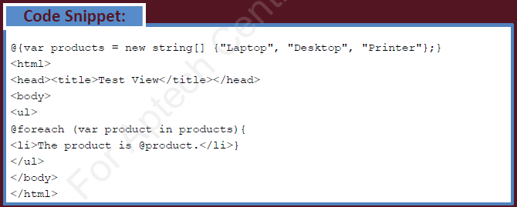

The MVC Framework uses a view engine to convert the code of a view into HTML markup that a browser can understand.

**Razor engine:**

* Is used as the default view engine by the MVC Framework.
* Compiles a view of your application when the view is requested for the first time.
* Delivers the compiled view for subsequent requests until you make changes to the view.
* Does not introduce a new set of programming language, but provides template markup syntax to segregate HTML markup and programming code in a view.

**A Razor:**

* First requires identifying the server-side code from the markup code to interpret the server-side code embedded inside a view file.
* Uses the @symbol, to separate the server-side code from the markup code.

**While creating a Razor view, you should consider following rules:**

* Enclose code blocks between @{ and }
* Start inline expressions with @
* Variables are declared with the var keyword
* Enclose strings in quotation marks
* End a Razor code statement with semicolon (;)
* Use the .cshtml extension to store a Razor view file that uses C# as the programing language
* Use the .vbhtml extension to store a Razor view file that uses VB as the programing language.

**In this lecture, we will learn**

* Inline expression statement.
* Declaring variable using **var** keyword.
* Multi statement code block.
* Conditional statement, if-else, switch.
* Loops.